**VISVESVARAYA TECHNOLOGICAL UNIVERSITY**

**“Jnana Sangama”, Belgaum -590014, Karnataka.**



**PROJECT WORK-2 REPORT**

**On**

**MEDILAB**

***Submitted by***

**SUDESHNA BHUSHAN (1BM19CS189)**

**NANDITA MAHENDRA (1BM19CS203)**

**RUBIANA JOSEPHINE PAUL (1BM19CS208)**

**DYUTHI ABHITHA PRAKASH (1BM19CS196)**

***Under the guidance of***

**Lohith J.J**

**Professor**

***in partial fulfillment for the award of the degree of***

**BACHELOR OF ENGINEERING**

***in***

**COMPUTER SCIENCE AND ENGINEERING**



**B.M.S. COLLEGE OF ENGINEERING**

**(Autonomous Institution under VTU)**

**BENGALURU-560019**

**JUNE 2021**

**B. M. S. College of Engineering,**

**Bull Temple Road, Bangalore 560019**

(Affiliated To Visvesvaraya Technological University, Belgaum)

**Department of Computer Science and Engineering**



**CERTIFICATE**

This is to certify that the project work entitled **“Medilab”** carried out by **SUDESHNA BHUSHAN (1BM19CS189), NANDITA MAHENDRA (1BM19CS203), RUBIANA JOSEPHINE PAUL (1BM19CS208), DYUTHI ABHITHA PRAKASH (1BM19CS196)** who are bonafide students of **B. M. S. College of Engineering.** It is in partial fulfillment for the award of **Bachelor of Engineering in Computer Science and Engineering** of the Visvesvaraya Technological University, Belgaum during the year 2021. The project report has been approved as it satisfies the academic requirements in respect of **Project Work-2(19CS4PWPW2)** work prescribed for the said degree.

Signature of the Guide                 Signature of the HOD

Prof. Lohith JJ Dr. Umadevi V.

Professor Prof & Head of Dept of CSE BMSCE, Bengaluru BMSCE, Bengaluru

External Viva

Name of the Examiner                                                               Signature with date

**B.M.S. College of EngineerinG**

**DEPARTMENT OF COMPUTER SCIENCE AND ENGINEERING**



**DECALARATION**

We, SUDESHNA BHUSHAN (1BM19CS189), NANDITA MAHENDRA (1BM19CS203), RUBIANA JOSEPHINE PAUL (1BM19CS208), DYUTHI ABHITHA PRAKASH (1BM19CS196) students of 4th Semester, B.E, Department of Computer Science and Engineering, BMS College of Engineering, Bangalore, hereby declare that, this Project Work-2 entitled **"Medilab"** has been carried out by us under the guidance of Prof. Lohith JJ, Professor, Department of CSE, BMS College of Engineering, Bangalore during the academic semester February-June 2021.

We also declare that to the best of our knowledge and belief, the development reported here is not from part of any other report by any other students.

Signature

**SUDESHNA BHUSHAN (1BM19CS189)**

**NANDITA MAHENDRA (1BM19CS203)**

**RUBIANA JOSEPHINE PAUL (1BM19CS208)**

**DYUTHI ABHITHA PRAKASH (1BM19CS196)**

**TABLE OF CONTENTS**

|  |  |  |
| --- | --- | --- |
| **Serial**  **No.** | **TITLE** | **PAGE NO.** |
| 1 | **Introduction** | 1 |
| 1.1 | Overview | 1 |
| 1.2 | Motivation | 2 |
| 2 | **Software Requirement Specification** | 3 |
| 2.1 | Hardware Requirements | 3 |
| 2.2 | Software Requirements | 3 |
| 3 | **Database Design Model** | 4 |
| 4 | **ER diagram of the project** | 5 |
| 5 | **Architecture Diagram** | 7 |
| 6 | **Database Diagram** | 8 |
| 7 | **Schema of project** | 9 |
| 8 | **Tables Used in the Project** | 10 |
| 9 | **Implementation And Issues** | 12 |
| 10 | **Software Testing** | 12 |
| 11 | **User Interface Design** | 13 |
| 12 | **Conclusion** | 28 |
| 13 | **References** | 29 |

**INTRODUCTION**

* 1. **Overview**

**Medilab** is a diagnostic lab that has implemented the **“LAB DATA MANAGEMENT SYSTEM”** to maintain its records of most of the aspects carried out in the laboratory such as appointments, emergency facilities, and many more. This project is general purpose “**Web Application**” that can perform several tasks such as enquiring facilities service for the patients and for the doctors and management a separate authentication portal is provided, from which two authentications are availed, one of the admins to manage and supervise the lab records by updating their reports through online or offline also. This project is build using Bootstrap framework in the front end and the php as the server-side scripting language on the platform of MySQL and it can be tested locally using XAMPP or WAMP servers.

**1.2 Motivation**

**General Introduction**

Medilab is a diagnostic lab that has implemented the “LAB DATA MANAGEMENT” to maintain its records of most of the aspects carried out in the laboratory such as appointments, emergency facilities, and many more

This project is general purpose “Web Application” that can perform several tasks such as enquiring facilities service for the patients. And for the doctors and management a separate authentication portal is provided, from which two authentications are availed, one of the admins to manage and supervise the lab records by updating their reports through online or offline also.

This web application is developed in such a way that it can be fitted to any of the devices such as desktops, laptops, tablets, hence it is a responsive web application.

The header line provides the immediate calling and mailing facility and also displays the hospital working hours.

The map is also displayed in the main page of the web application.

Login is must and required to get the appointment whereas there is no need of any formalities to book the ambulance for emergency cases.

**Objective of this Project:**

* To provide an online platform to the patients to get the appointments.
* To provide the user-friendly environment
* The management can easily supervise the system and have a good control over each and every records.
* To make it easy to use for everyone.
* To work fast and accurate.
* To be time efficient.

## **Advantages:**

* Easy to use.
* User-friendly
* Attractive
* Anyone can understand the concepts of laboratory.
* Minimized data-entry.
* Saved a lot of paper work.
* Saves lot of time.
* Reduced risk of accuracy.
* Minimized effort and time.
* Fast processing time.

**SOFTWARE REQUIREMENTS**

**Hardware requirements:**

* Processor - i3 or higher
* RAM - 2GB or higher
* HDD/SDD - 120GB
* Device - Laptop/desktop/tablet/cell-phone

**Software requirements:**

* Frontend - Bootstrap Framework (HTML, CSS, JS)
* Backend - MySQL
* Server Scripting Language - PHP
* Operating System- Windows 7 or higher
* IDE - Microsoft VS Code
* Text Editor - Brackets
* Local Server - XAMPP
* Search Engine -Chrome/Mozilla

# **DATABASE DESIGN MODEL**

## **INTRODUCTION**

Major steps in database design model-

* Requirements Analysis:
* Talk to the potential users, understand what is to be stored, and operations and requirements are desired.
* Conceptual Database Design:
* Develop a high-level description of the data and constraints.
* Logical Database Design:
* Convert the conceptual model to be schema in the chosen data model of the DBMS. Converting the conceptual to a relational schema.
* Schema
* Refinement: Look for potential problems in the original choice of schema and try to redesign.
* Physical Database Design: Direct the DBMS into choice of underlying data layout in hopes of optimizing the performance.
* Application and security Design:
* How will the underlying database interact with surrounding applications?

**3. ER DIAGRAM OF THE PROJECT**

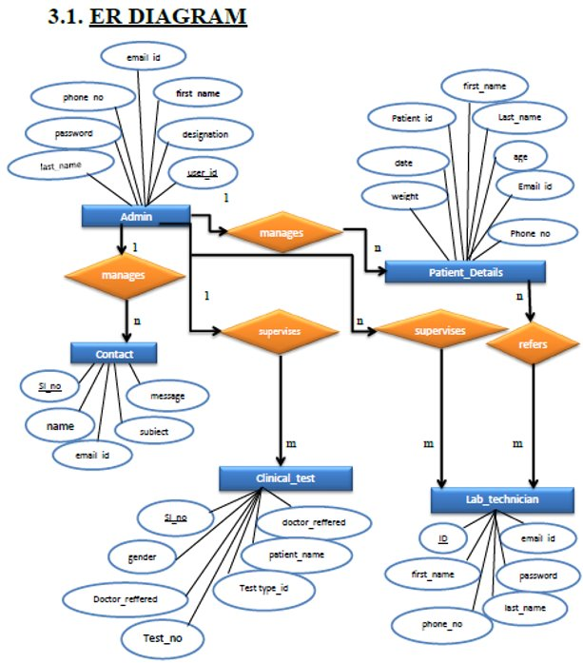

**DATABASE DIAGRAM**

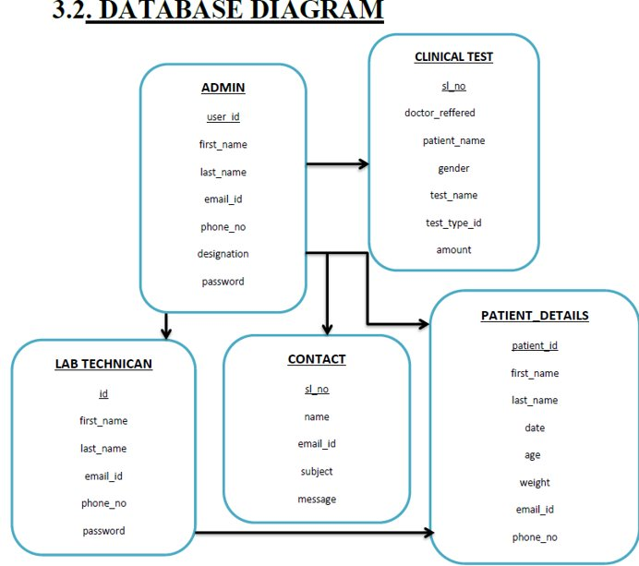

**ARCHITECTURE DIAGRAM**

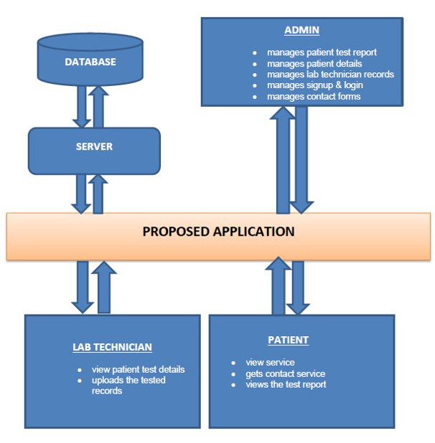

**4. SCHEMA OF THE PROJECT**

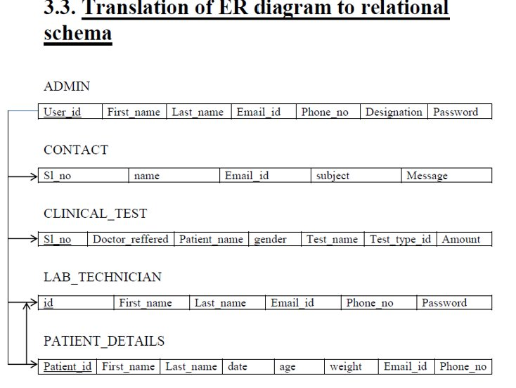

**TABLES USED IN THE PROJECT**

## **ADMIN**

|  |  |
| --- | --- |
| **COLUMN** | **TYPE** |
| **User_id** | **Bigint(250)** |
| **First_name** | **Varchar(200)** |
| **Last_name** | **Varchar(200)** |
| **Email_id** | **Varchar(200)** |
| **Phone_no** | **Bigint(200)** |
| **Designation** | **Varchar(200)** |
| **password** | **Varchar(200)** |
|  |  |

**CONTACT**

|  |  |
| --- | --- |
| **COLUMN** | **TYPE** |
| **Sl_no** | **Bigint(250)** |
| **Name** | **Varchar(200)** |
| **Email_id** | **Varchar(200)** |
| **Subject** | **Varchar(200)** |
| **message** | **Varchar(200)** |

## **CLINICAL TEST**

|  |  |
| --- | --- |
| **COLUMN** | **TYPE** |
| **Sl_no** | **Bigint(250)** |
| **Doctor_reffered** | **Varchar(200)** |
| **Patient_name** | **Varchar(200)** |
| **Gender** | **Varchar(200)** |
| **Test_name** | **Varchar(200)** |
| **Test_type_** | **Varchar(200)** |
| **amount** | **Varchar(200)** |

**LAB TECHNICIAN**

|  |  |
| --- | --- |
| **COLUMN** | **TYPE** |
| **id** | **Bigint(250)** |
| **First_name** | **Varchar(200)** |
| **Last_name** | **Varchar(200)** |
| **Email_id** | **Varchar(200)** |
| **Phone_no** | **Varchar(200)** |
| **password** | **Varchar(200)** |

## **PATIENT_DETAILS**

|  |  |
| --- | --- |
| **COLUMN** | **TYPE** |
| **Patient_id** | **Bigint(250)** |
| **First_name** | **Varchar(200)** |
| **Last_name** | **Varchar(200)** |
| **Date** | **Date** |
| **Age** | **Bigint(200)** |
| **Weight** | **Varchar(200)** |
| **Email_id** | **Varchar(200)** |
| **Phone_no** | **Varchar(200)** |

**REPORT**

|  |  |
| --- | --- |
| **COLUMN** | **TYPE** |
| **Sl_no** | **Bigint(250)** |
| **First_name** | **Varchar(200)** |
| **Last_name** | **Varchar(200)** |
| **Gender** | **Varchar(200)** |
| **Test_name** | **Varchar(200)** |
| **Test_id** | **Varchar(200)** |
| **Date** | **Date** |
| **Time** | **Time** |
| **Test1** | **Varchar(200)** |
| **Result1** | **Varchar(200)** |
| **Units** | **Varchar(200)** |
| **Standards1** | **Varchar(200)** |
| **Bio_ref1** | **Varchar(200)** |
| **methodology** | **Varchar(200)** |

**SIGNUP**

|  |  |
| --- | --- |
| **COLUMN** | **TYPE** |
| **Sl_no** | **Bigint(250)** |
| **First_name** | **Varchar(200)** |
| **Last_name** | **Varchar(200)** |
| **Email_id** | **Varchar(200)** |
| **Create_password** | **Varchar(200)** |
| **Confirm_password** | **Varchar(200)** |

# **IMPLEMENTATION AND ISSUES**

**Implementation details**

Implementation is the stage of project where the theoretical design is turned into a working system. It can be considered to be the most crucial stage in achieving a successful new system gaining the users confidence that the new system will work and will be effective and accurate. It primarily concerned with user training and documentation.

Conversion usually takes place about the same time the user is being trained or later. Implementation simply means convening a new system design into an operational one.

If the implementation is not carefully planned and controlled. It can create confusion.

Implementation includes all those activities that take place to convert from the existing system to the new system. The new system may be totally new. Proper implementation is essential to provide a reliable system to meet organization requirements. The process of putting developed system in actual use is called system implementation. This includes all those activities that takes place to convert from the old system to the new system.

# **SOFTWARE TESTING**

The process of executing a system with the intent of finding errors can be defined as testing. It can also be defined as the process that defines as the process that defines, isolates, subjects to rectification of defects, and so that the customer satisfaction is reached at last with assurance of the system is free from defects.

Software testing is a very important element of the quality assurance and it represents the SRS, designing, coding and implementation of the system proposed.

## **5.1. TEST CASES**

**ADMIN LOGIN**

|  |  |  |
| --- | --- | --- |
| **INPUT** | **RESULT** | **CONCLUSION** |
| **LOGIN TYPE: email & password**   1. **admin email_id; user input** 2. **password; user input** | **Admin is allowed to access the clinical test records, & supervise the staff** | **Admin has to give the register email_id and password in order to access the system, if either email_id or password is wrong an error method is displayed** |

**Technician Login**

|  |  |  |
| --- | --- | --- |
| **INPUT** | **RESULT** | **CONCLUSION** |
| **LOGIN TYPE: email & password**   1. **admin email_id; user input** 2. **password; user input** | **Admin is allowed to access the clinical test records, & supervise the staff** | **Admin has to give the register email_id and password in order to access the system, if either email_id or password is wrong an error method is displayed** |

**User Login**

|  |  |  |
| --- | --- | --- |
| **INPUT** | **RESULT** | **CONCLUSION** |
| **LOGIN TYPE: email & password**   1. **admin email_id; user input** 2. **password; user input** | **Admin is allowed to access the clinical test records, & supervise the staff** | **Admin has to give the register email_id and password in order to access the system, if either email_id or password is wrong an error method is displayed** |

**CONTACT**

|  |  |  |
| --- | --- | --- |
| **INPUT** | **RESULT** | **CONCLUSION** |
| **1.name: user input 2. email_id: user input**  **3. subject; user input**  **4. message; user input** | **Records should be uploaded or saved successfully and a popup box will show “your message has sent”** | **User contact details are saved successfully if call the fields are entered otherwise an alert message is displayed.** |

**ADD PATIENTS TEST DETAILS**

|  |  |  |
| --- | --- | --- |
| **INPUT** | **RESULT** | **CONCLUSION** |
| 1. **Doctor Referred: user input** 2. **Patient**   **Name (First/Last): user input**   1. **Gender: choose from the list** 2. **Test Name: choose from the list** 3. **Test ID: choose from the list** 4. **Amount: choose from the list** | **After filling the required data and ticking on in the confirmation box.**  **Lab technician is proceeded to the step 2 to fill the patient details to carry out the lab test, taken/opted by the patient.** | **Lab technician has to fill the details of patient in order to do/proceed next step.** |

**ADD PATIENTS’ DETAILS**

|  |  |  |
| --- | --- | --- |
| **INPUT** | **RESULT** | **CONCLUSION** |
| 1. **First Name: user input** 2. **Last Name: user input** 3. **Date: choose from the list** 4. **Age: user input** 5. **Weight: user input** 6. **Email ID: user input** 7. **Phone Number: user input** | **After filling the required data and ticking on in the confirmation box.**  **Lab technician is proceeded to the step 2 to fill the patient details to carry out the lab test, taken/opted by the patient.** | **Lab technician has to fill the details of patient in order to do/proceed next step.** |

**Report**

|  |  |  |
| --- | --- | --- |
| **INPUT** | **RESULT** | **CONCLUSION** |
| 1. **Sl no: user input** 2. **First name: user input** 3. **Last name: user input** 4. **Gender: choose from the list** 5. **Test name: choose from the list** 6. **Test ID: user input** 7. **Date: choose from the list** 8. **Time: choose from the list** 9. **Test1: choose from the list** 10. **Result1: choose from the list** 11. **Units: choose from the list** 12. **Standards1: user input** 13. **Bio ref1: user input** 14. **Methodology: user input** | **After filling the required data and ticking on in the confirmation box.**  **Lab technician will get a confirmation message that the report is successfully uploaded.** | **Lab technician has to fill the details of patient in order to do/proceed next step** |

**USER INTERFACE DESIGN**

**FIGURE 1: Homescreen**

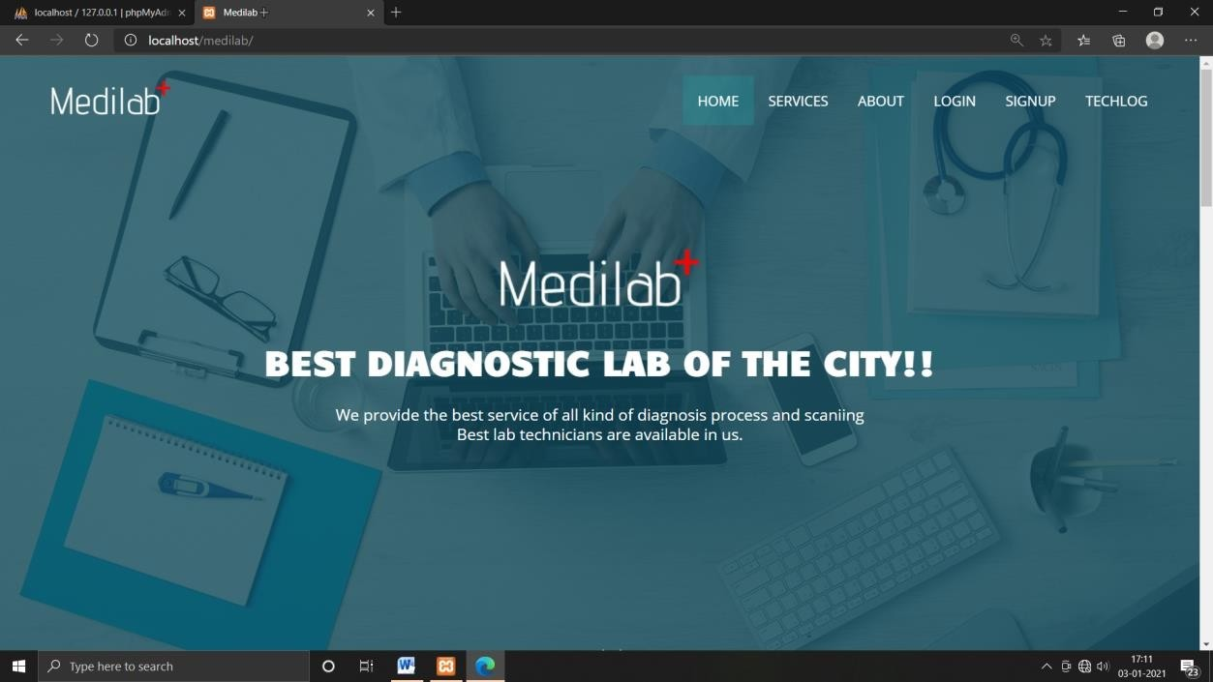

**This is the home page of the site; this page get displays soon after visiting the site. It contains services about login, signup, services, about, Techlog.**

**FIGURE 2: SERVICES OFFERED FORM:**

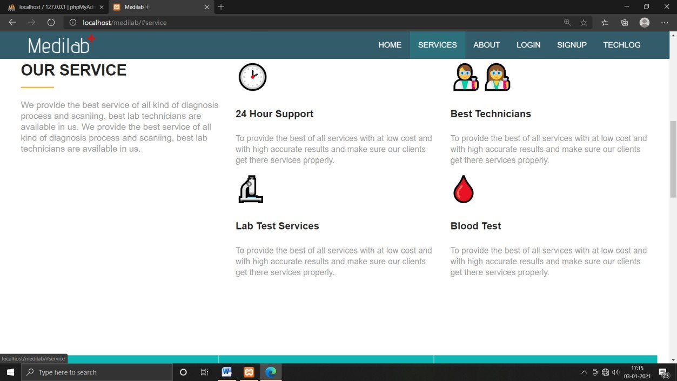

**FIGURE 3: ABOUT US:**

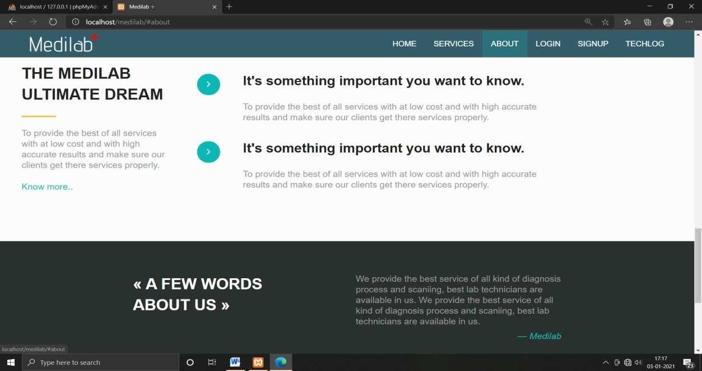

**FIGURE 4: PATIENT SIGNUP FORM:**

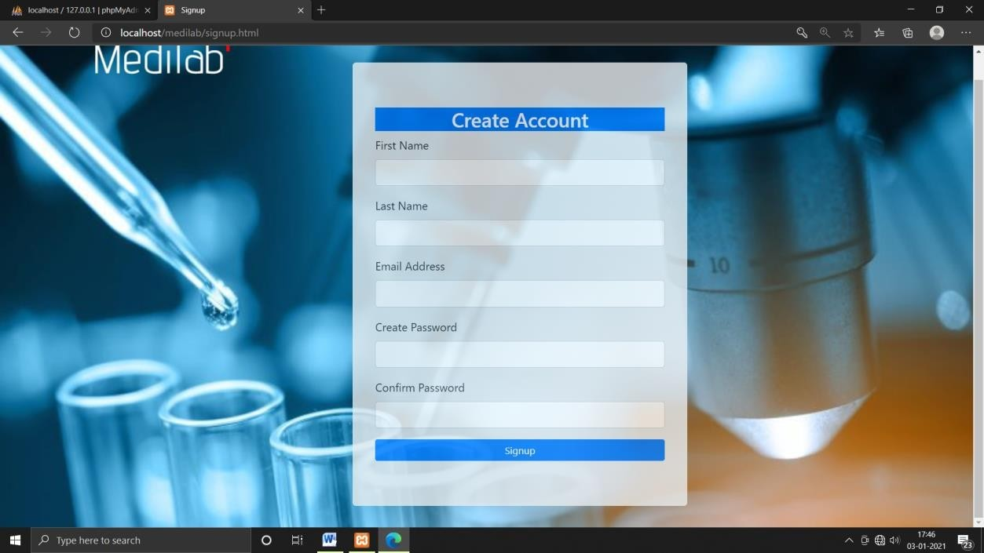

**FIGURE 5: PATIENT LOGIN:**

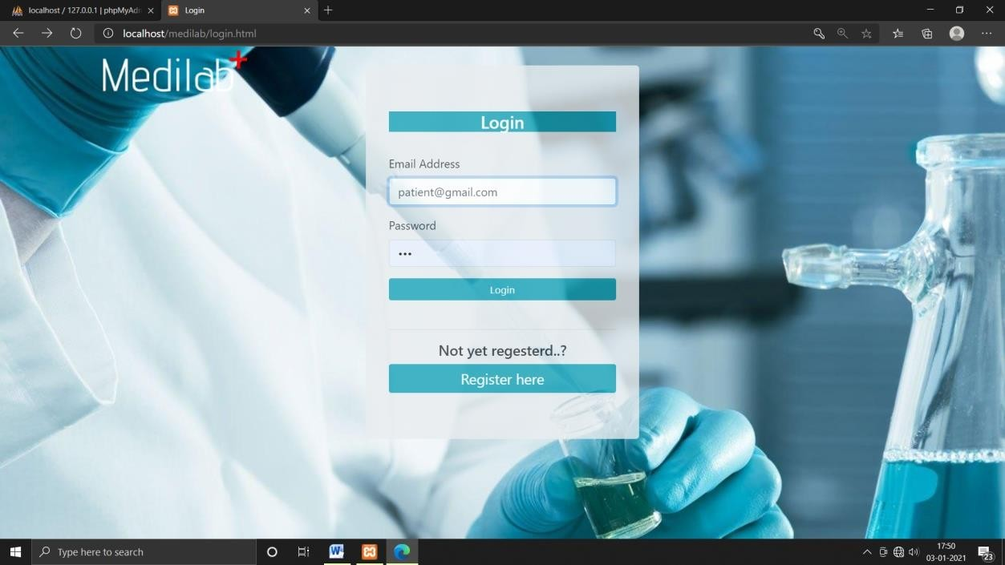

**FIGURE 6: LAB TECHNICIAN LOGIN:**

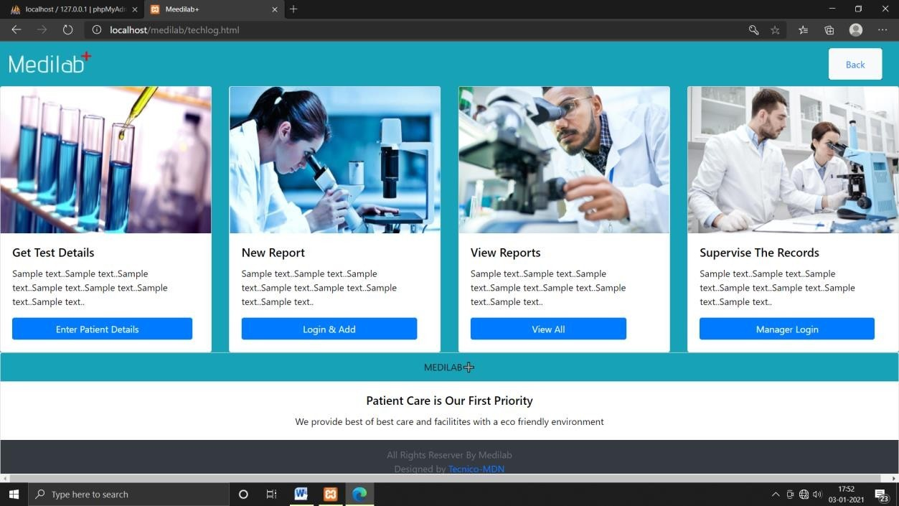

**FIGURE 7: ENTER PATIENT DETAILS:**

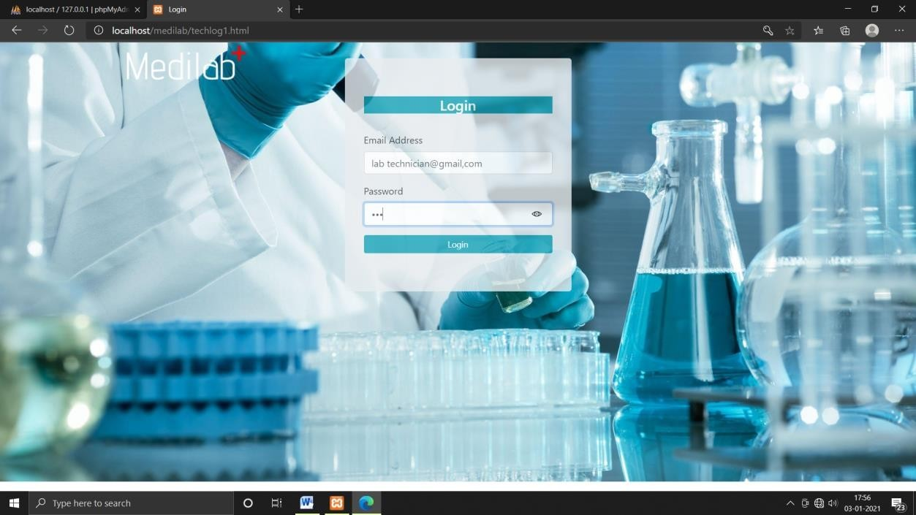

**FIGURE 8: LAB TEST DETAILS:**

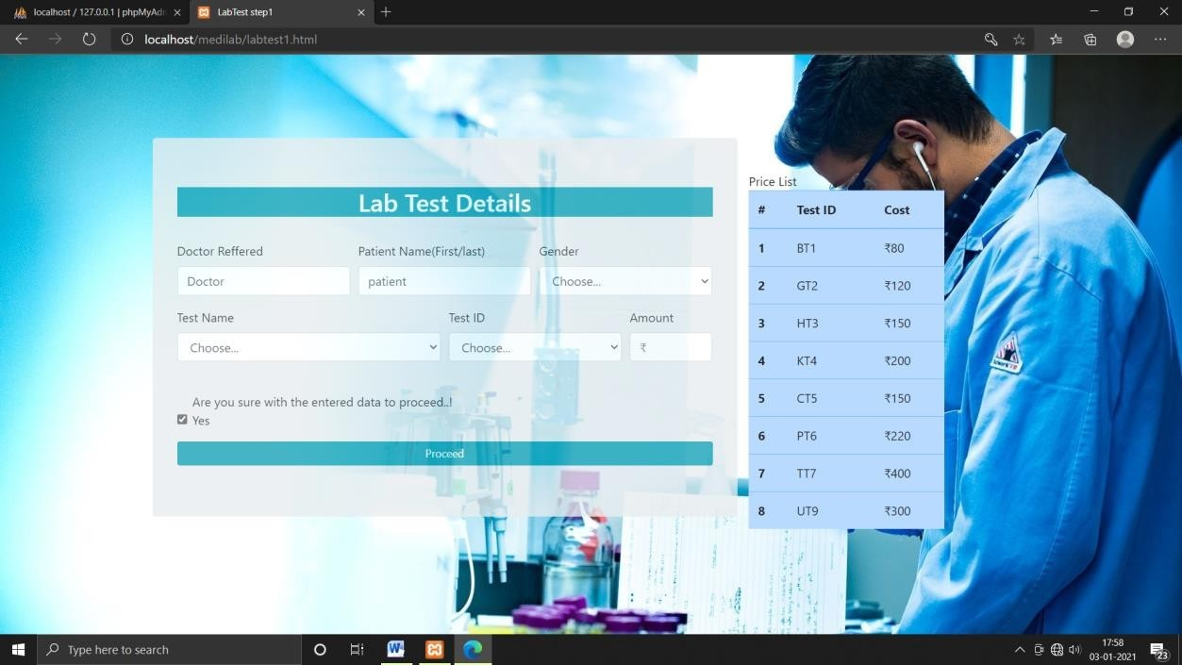

**FIGURE 9: PATIENT INFO:**

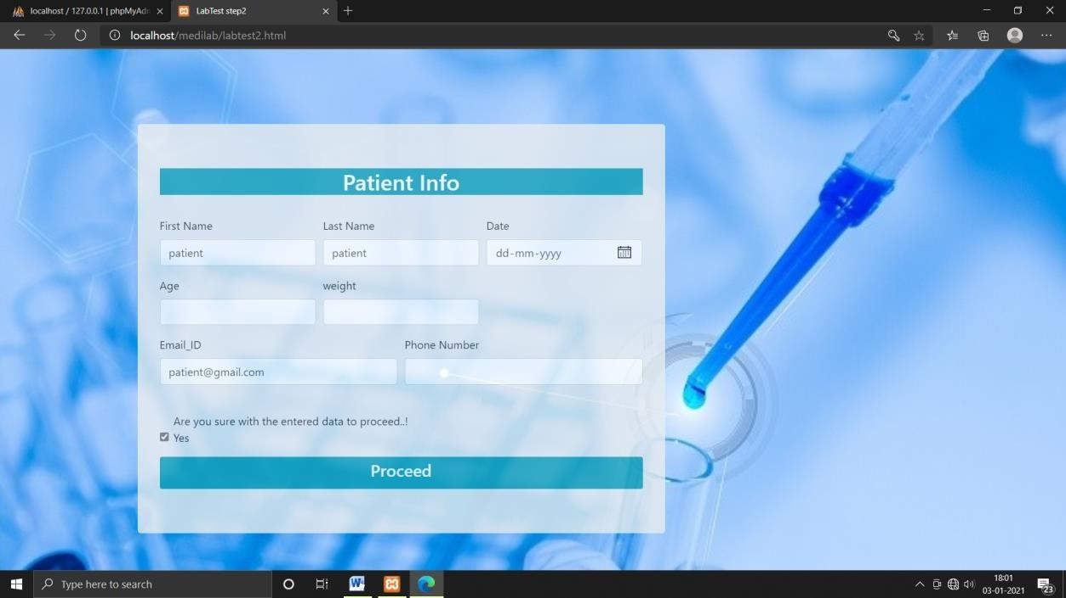

**FIGURE 10: DISPLAYING THE PATIENT DETAILS:**

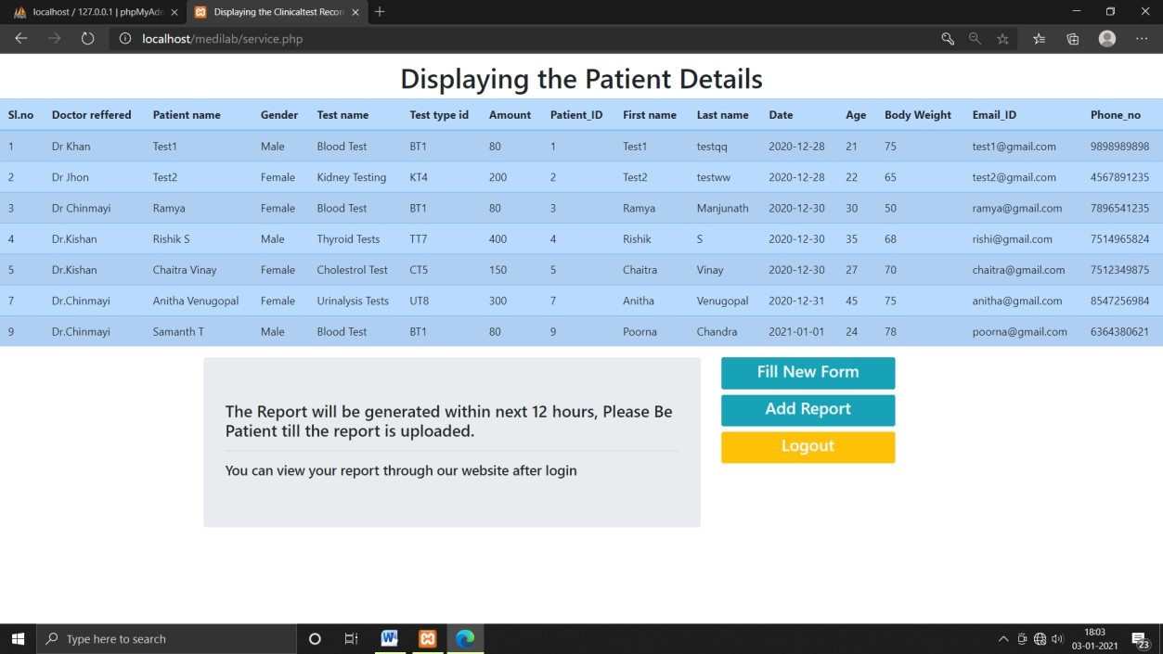

**FIGURE 11: ADD REPORT(LAB TEST DETAILS):**

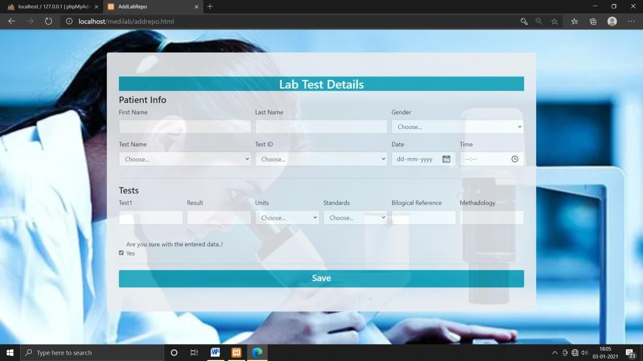

**FIGURE 12: REPORT GENERATED AND LOGOUT FROM THE PAGE:**

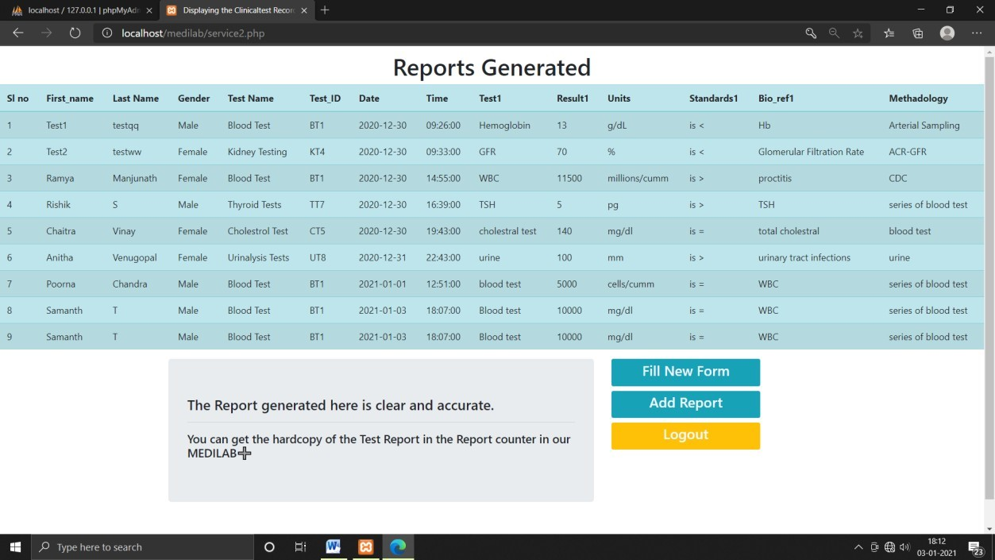

**FIGURE 13: LOGIN TO GET REPORT:**

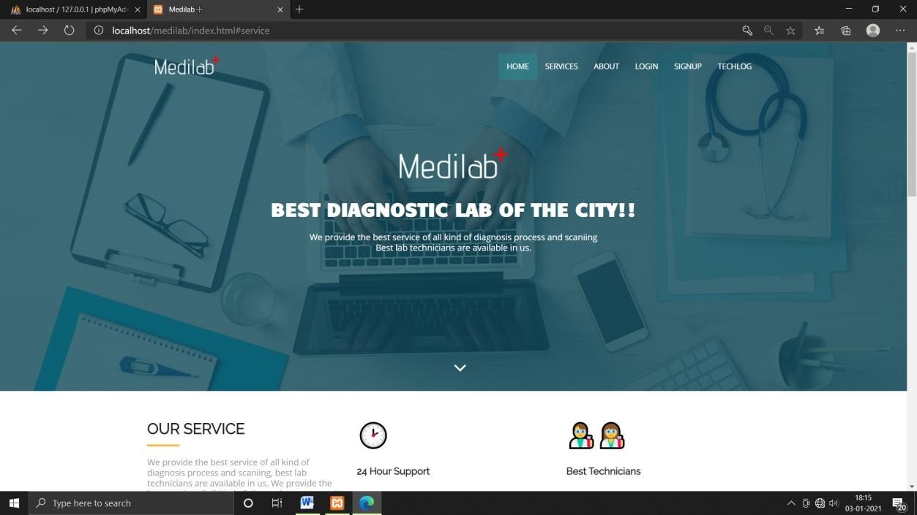

**FIGURE 14: PATIENT LOGIN TO GET REPORT:**

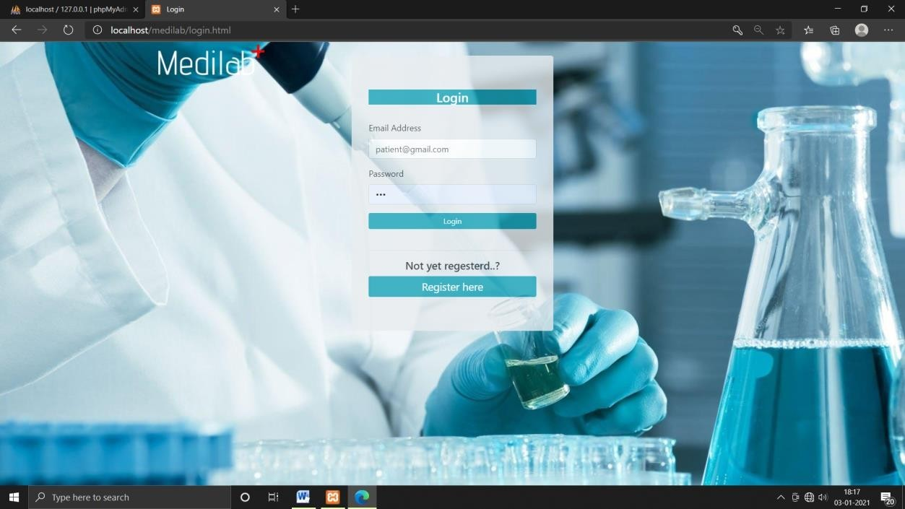

**FIGURE 15: VIEW LAB REPORT:**

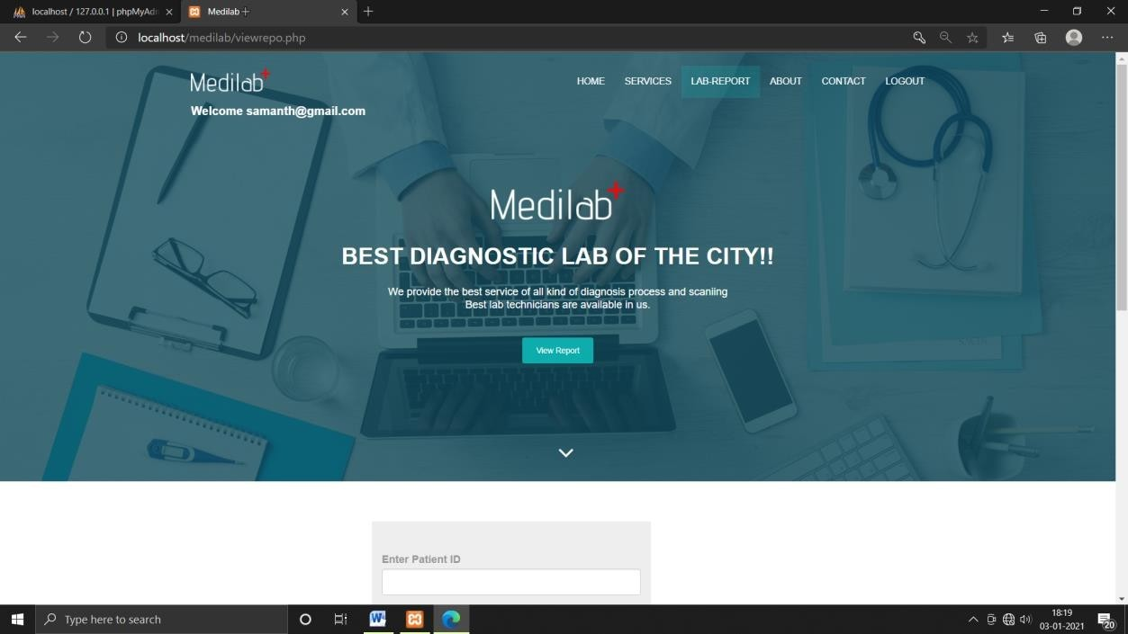

**FIGURE 16: ENTER VALID PATIENT ID:**

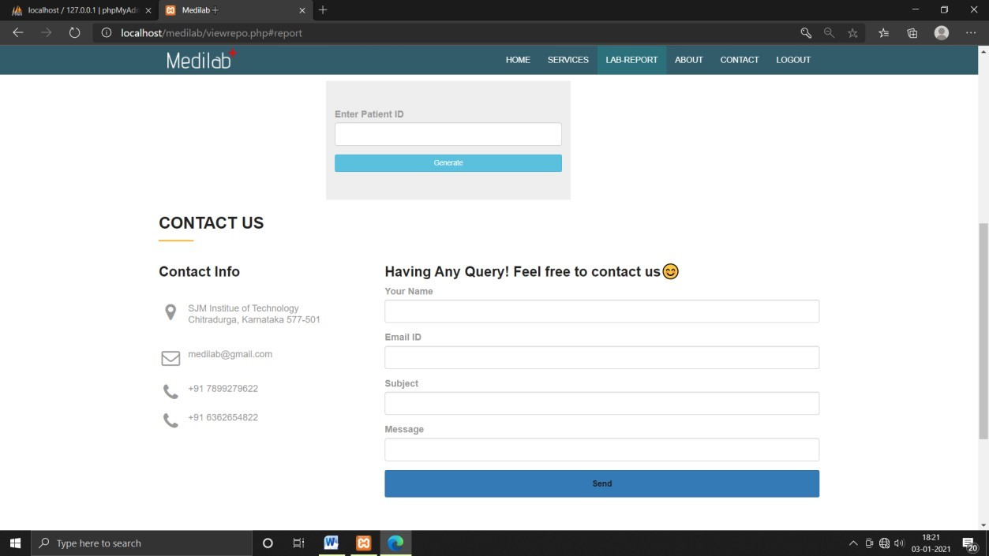

**FIGURE 17: REPORT GENERATED:**

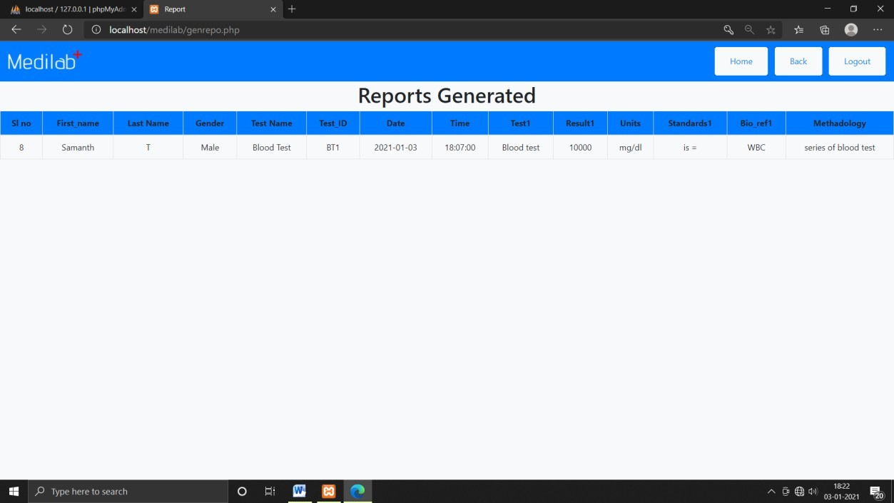

# **Conclusion**

The “LAB DATA MANAGEMENT” is a database management system adopted by the lab named “MEDILAB” to have a general-purpose web application in which both the laboratory staff and the clients/patients can get the benefit from it.

* It is developed in such a way that the patients can book an appointment online through our website where as well can get the ambulance service, whereas the doctors can view their appointment schedule and above all, the hospital management can easily supervise and maintain the records of doctors, patients, emergency service, email subscriptions and contact forms and have complete control over it.
* This project is an attempt to provide a platform to the users and service providers to save time and maintain accuracy with reduced paperwork and time and to provide the details of the service provider to the client, so that they can understand and learn about the facilities provided by the service provider (Hospital).

**REFERENCES:**

* + - [https://www.w3schools.com](https://www.w3schools.com/)
    - [https://www.eduonix.com](https://www.eduonix.com/)
    - [https://fonts.google.com](https://fonts.google.com/)